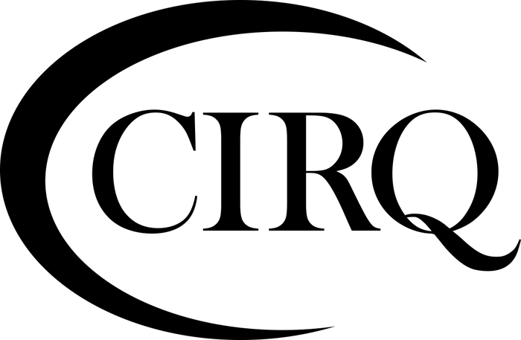
1629 K Street, NW – Suite 300 | Washington, DC 20006 | USA

ISO 20252/ISO 27001
STANDARD CERTIFICATION AGREEMENT

APPLICANT INFORMATION
Applicant Name: | Applicant Address:
Contact Name: | Telephone Number:
Title: | Email:
Agreement Effective Date: | Facsimile Number:

ISO STANDARDS FOR CERTIFICATION
[ ] ISO 20252:2019 | [ ] ISO/IEC 27001:2022

This Certification Agreement (the “Agreement”) is effective as of the Agreement Effective Date (defined on the cover page), by and between the Certification Institution for Research Quality (CIRQ), LLC (“CIRQ”), a Delaware limited liability company, with an address at 1629 K Street NW, Suite 300 Washington, DC 20006, USA, and Applicant, with the address set forth on the cover page hereto.

WHEREAS, CIRQ is a certifying organization, conforming to the requirements for bodies operating certification product and service systems (ISO/IEC 17065:2012) and requirements for bodies providing audit and certification of management systems (ISO 17021:2015-1) of the International Standards Organization (“ISO”), for ISO Standard 20252:2019 (market, opinion and social research including insights and data analytics) and ISO/IEC 27001:2022 (information security management systems), (the “Standards”).

WHEREAS, Applicant desires to receive certification in one or both of the Standards and desires to retain CIRQ to provide auditing and certification services (the “Services”) to Applicant; and

WHEREAS, CIRQ desires to provide the Services subject to the following terms and conditions:

NOW, THEREFORE, for good and valuable consideration, the receipt and sufficiency of which are hereby acknowledged, the parties agree as follows:

1. The Certification Process

- APPLICATION PROCESS:
  - ISO 20252:2019: Applicant completes a Request for Quotation Form and receives an Estimated Cost Quotation from CIRQ. The Applicant returns the Authorization to Proceed along with Application Fee.
  - ISO 27001:2022 Applicant completes MS Application and receives an Estimated Cost Quotation from CIRQ. The Applicant returns the Authorization to Proceed along with Application Fee.
- SELF-ASSESSMENT:
  - ISO 20252:2019: Applicant completes the Self-Assessment workbook. The Self-Assessment and the company’s Quality Manual are returned to CIRQ electronically with other attachments as requested within the document. Payment for the Pre-Assessment must also be sent at this time.
- PRE-ASSESSMENT PROCESS:
  - ISO 20252:2019: The Self-Assessment and Quality Manual are now reviewed against the ISO Standard and Statement of Applicability on Application to determine completeness and Applicant’s preparedness for certification. A Pre-Assessment Report is provided to the Applicant on completion of this process.

  - ISO 27001:2022: A Stage 1 Audit is planned with Client.

- PLANNING THE AUDIT: This is the stage when CIRQ and the Client communicate to plan and arrange the onsite audit. The Applicant will be required to sign off (email acceptable) on the Audit Schedule and pay 50% of the initial Certification Audit costs prior to proceeding with the on-site audit. The Client is permitted to request the participation of observers during an audit, as appropriate to the facilitation of the audit schedule and scope (e.g., project managers, annex owners, quality and compliance representatives, etc.). CIRQ may also request of the Client to make provisions, where applicable, to accommodate the presence of observers (e.g. accreditation assessors or trainee auditor).
- EXECUTION OF THE AUDIT:
  - ISO 20252:2019: This is the on-site audit process. Unless otherwise indicated in an Audit Schedule, Client headquarters will always be the first location audited followed by other locations as per the Audit Schedule.
  - ISO 27001:2022: A Stage 2 Audit is planned. Client headquarters will always be the first location audited followed by other locations as per the Audit Schedule.

- AUDIT REPORT: As a result of the audit, an Audit Report is prepared by the Auditor/s and submitted to CIRQ. The Final Audit Report is approved by CIRQ management prior to being sent to the Client. In the case where the Client provides copies of the certification documents to others (e.g., Audit Report), the document shall be reproduced in its entirety (PDF file format).
  - Initial Certification Audits for ISO 20252:2019 shall be reviewed by Managing Director and approved by CIRQ Board Chair to ensure impartiality.
  - Initial Certification Audits for ISO 27001:2022 shall be approved by an appointed knowledgeable and competent Technical Advisor for Certification Review and approved by the CIRQ Managing Director to ensure impartiality.
- CERTIFICATION: When the auditor designated by CIRQ as the “Lead Auditor” is satisfied that Applicant’s quality system documentation and implementation meet the requirements of the applicable Standard, a recommendation will be made to CIRQ by the Lead Auditor to issue a Certificate of Compliance (a “Certificate”). On approval by the Managing Director of CIRQ, CIRQ will issue a Certificate (or Certificates if multiple locations involved) with respect to the applicable Standard, and the certification register (the “Register”) on the CIRQ website will be updated with Applicant’s name, address, effective and expiration dates, and the details of the Statement of Applicability from the Applicant’s certification. In the case where the Client provides copies of the certification documents to others (e.g., Certificate), the document shall be reproduced in its entirety (PDF file format).

- FIRST AND SECOND SURVEILLANCE AUDITS: Certification is valid for three (3) years subject to ongoing surveillance audits, which occur in approximately twelve (12) month intervals, subject to scheduling. CIRQ will advise Applicant of any change to the surveillance audit schedule.

- RE-CERTIFICATION AUDIT: Prior to the expiration of certification, CIRQ will perform a re-certification audit of Applicant’s total research management system and/or information security management system. A successful reassessment will result in renewal of Applicant’s Certificate for an additional three-year term. Where CIRQ cannot conduct or complete the re-certification audit prior to the expiration of the Applicant’s Certificate, CIRQ will grant a reasonable extension until CIRQ can complete the re-certification audit.

Applicant may reduce or expand its certification, either in terms of Statement of Applicability or in terms of number of ISO standards to which the Applicant chooses to attempt to have certified.

CIRQ shall provide document reviews, audits, and certification (assuming the conditions are met) in accordance with CIRQ’s procedures. CIRQ reserves the right to modify such procedures at any time upon reasonable notice.

CIRQ shall not be liable in any respect should CIRQ be prevented from discharging its obligations because of Applicant’s delay or failure to cooperate in a timely and complete manner in the certification process, including in providing complete and accurate information to CIRQ and making its facilities and personnel available to CIRQ auditors.

CIRQ shall use commercially reasonable efforts to cause its auditors to observe safety, security and other lawful instruction when on Applicant’s premises.

2. Suspension, Withdrawal or Termination of Certification

- Applicant acknowledges that the requirements for certification are determined by the ISO and may be changed at any time in the ISO’s sole discretion and, in the event of any such change that occurs after CIRQ’s certification of Applicant, (i) CIRQ shall (x) be entitled to withdraw certification and or re-certify Applicant pursuant to the requirements of ISO and (y) have no liability to Applicant due to such change, withdrawal or re-certification; and (ii) Applicant shall be responsible for all costs, including payment of CIRQ’s fees to re-certify Applicant, with regard to such change, withdrawal and re-certification.

- CIRQ reserves the right to suspend, terminate or withdraw certification in the event that CIRQ determines in its reasonable discretion that Applicant has failed to comply with any of the terms and conditions of this Agreement, the CIRQ Quality Manual or other direction or requirement of CIRQ or ISO in the certification process or the use or maintenance of the certification, including but not limited to:

- Failure to complete corrective actions within an agreed timeframe; or
- Misuse the Certification Mark(s) (as defined herein); or
- A material breach of the terms and conditions of this Agreement, including the failure to pay any amounts due CIRQ in a timely manner; or
- Bringing CIRQ or ISO into disrepute in any way.

CIRQ will assist Applicant to take appropriate remedial action following suspension of certification, but in the event that Applicant fails to take remedial actions within a reasonable amount of time, CIRQ may withdraw certification. Applicant may also request withdrawal of certification at any time.

- Certification Suspending, withdrawing, or reducing certification process: ISO/IEC 27001:2022
    - the client’s certified management system has persistently or seriously failed to meet certification requirements, including requirements for the effectiveness of the management system
    - the certified client does not allow surveillance or recertification audits to be conducted at the required frequencies
    - the certified client has voluntarily requested a suspension.
      - All suspensions result in the client’s management system certification as temporarily invalid.
CIRQ shall restore the suspended certification if the issue that has resulted in the suspension has been resolved. Failure to resolve the issues that have resulted in the suspension in 45 days shall result in withdrawal or reduction of the scope of certification. Note: In most cases, the suspension would not exceed six months.
The certification body shall reduce the scope of certification to exclude the parts not meeting the requirements when the certified client has persistently or seriously failed to meet the certification requirements for those parts of the scope of certification. Any such reduction shall be in line with the requirements of the standard used for certification.

- Where suspension, termination or withdrawal of certification occurs, CIRQ will update its online Register to reflect the specific action. Upon suspension, termination or withdrawal of certification, Applicant shall immediately: (i) return to CIRQ the Certificate(s); (ii) discontinue the use of the Certification Mark(s) in any way; (iii) return copies of certification documents; and (iv) discontinue use of all advertising matter that contains any reference thereto.

  - Complaints and Appeals Procedure.

Applicants may appeal to CIRQ any application or certification-related decision or submit a complaint to CIRQ regarding the staff of CIRQ or its activities related to the auditing or certification process. In addition, companies and individuals may file complaints with CIRQ regarding other companies certified by CIRQ. All complaints and appeals shall be handled in accordance with the procedures set forth in the CIRQ Quality Manual. All certification decisions made by CIRQ shall be at its sole discretion.

4. Fees.

- Subject to Section 4.B, Applicant shall pay all fees and charges described on the most recent Estimated Cost Quotation (Exhibit A) to achieve Applicant’s initial certification, and all fees and charges for subsequent surveillance and re-certification audits and management fees at CIRQ’s standard rates then in effect. CIRQ reserves the right to adjust its standard fee schedule upon ninety (90) days prior written notice to Applicant. The applicable fees may include an application fee, pre-assessment fee, audit fee, travel time fee, report writing fee, certification fee and annual management fee. Application and pre-assessment fees will be due and payable by Applicant upon execution of this Agreement. All fees and charges are non-refundable.

- Audit fees for the initial certification audit as well as any surveillance or re-certification audits are based on the actual number of auditor days required to conduct and complete the audit. The Estimated Cost Quotation provides only CIRQ’s reasonable estimation, based on several factors, of the number of auditor days that will be required to conduct and complete the audit. Accordingly, CIRQ makes no representation, warranty or covenant regarding the accuracy of the estimate of audit days set forth in the Estimated Cost Quotation and, notwithstanding such estimate, Applicant shall pay audit fees based on the actual number of audit days required to conduct and complete the audit, provided that, without limiting Applicant’s obligation to pay such audit fees, CIRQ will use reasonable efforts to notify Applicant in advance if CIRQ determines that the actual number of audit days required to conduct and complete the audit is likely to be greater than the estimated number of audit days.

- Applicant shall only incur certificate fees in the event that CIRQ issues a Certificate to Applicant.

- CIRQ will charge management fees annually on the anniversary of the issuance of the Certificate; provided, however, that management fees will only be charged in the event that Applicant continues to pursue or maintain certification from CIRQ.

- Applicant shall pay fees as follows:

- Fees incurred in connection with the self-assessment and audit preparation phase, including self-assessment, pre-assessment and audit plan shall be due:
  - 50% upon execution of this Agreement; and
  - 50% within 14 days of completion of the audit plan
- Fees incurred in connection with the audit phase, including the audit fee, travel time fee and report writing fee shall be due:
  - 50% prior to scheduled commencement of the audit (based on the estimated number of audit days); and
  - 50% within 14 days of delivery of the audit report to Applicant (with adjustment based on the actual number of audit days and including travel expenses)
- Certification fees shall be due prior to issuance of the Certificate
- Fees incurred in connection with subsequent surveillance and with re-certification audit shall be due:
  - 100% prior to scheduled commencement of the surveillance or re-certification audit (based on the estimated number of audit days, as applicable)

- In no event shall CIRQ perform any services or issue any Certificate unless and until Applicant has fully paid all fees due and payable for the prior phase(s) of services.

- For late payments, interest will be charged on the outstanding balance at the rate of 1% per month or the maximum interest rate allowed by law, whichever is less.

- Should Applicant postpone or cancel an arranged Audit, Applicant shall pay all unavoidable expenses of CIRQ and for any completed audit days.

- Any taxes on the Services, other than taxes on the income of CIRQ, shall be the responsibility of Applicant.

5. Term and Termination

This Agreement shall commence on the Agreement Effective Date and continue for so long as Applicant utilizes the Services, pursuing or maintaining certification from CIRQ to one or both of the Standards.

6. Applicant Representations, Warranties, and Covenants

- Applicant hereby represents and warrants that all documents and information supplied to CIRQ for the purposes of this Agreement and/or CIRQ’s delivery of the Services, including, without limitation, the Application, Self-Assessment and Applicant’s quality system documentation, are complete and accurate in all material respects and do not omit any material fact. Applicant also covenants to notify the Managing Director of CIRQ in writing of any changes or conditions that could negatively affect CIRQ’s decision to issue or maintain Applicant’s certification (including, without limitation, substantial customer complaints, material litigation, or government investigations). CIRQ shall also be given access to all relevant materials in relation to such negative conditions.

- Applicant hereby warrants and covenants to CIRQ that Applicant will at all times during the term of this Agreement comply with all reasonable requirements (the “Rules and Requirements”) in connection with Applicant’s use of the Services, including without limitation, whatever is necessary with respect to the issuance and maintenance of the Certificate. For purposes herein, the Rules and Requirements, include but are not limited to, all statutes, rules, regulations issued by any government authority; all recommendations, codes or similar matters issued by the ISO; or such other reasonable requirements as are necessary to enable Certification to be issued and maintained.

- Applicant shall provide CIRQ with all documents, information and facilities as necessary to enable CIRQ to provide the Services.

- Applicant must notify CIRQ in advance to discuss the consequences of any changes to its certified quality system, a move, restructuring, or change in ownership, a new product line or change to any process that affects the Statement of Applicability. If the change occurs after certification has been granted, it may be necessary to modify the assessment schedule and/or to change the Statement of Applicability.

- Applicant must establish and maintain procedures for notifying its clients of any goods or services that it provides or produces that are outside the scope of the certification issued and registered by CIRQ.

  - Confidentiality and Intellectual Property Ownership

- All information and documentation obtained from or provided by Applicant during the audit and certification process (“Applicant Confidential Information”) shall be treated by CIRQ, and its employees and agents, as confidential and shall not be disclosed to any third party without the Applicant’s written consent. Unless authorized by Applicant in writing, details of applications for certification are treated as confidential; provided, however, that upon certification, CIRQ will make the scope of certification public.

- Any information or documentation obtained from or provided by CIRQ that is designated as “confidential” by CIRQ or which Applicant should reasonably understand to be confidential (“CIRQ Confidential Information,” and together with Applicant Confidential Information, “Confidential Information”) shall be treated by Applicant, and its employees and agents, as confidential and shall not be disclosed to any third party without CIRQ’s written consent.

- The receiving party may disclose Confidential Information to its employees and/or agents solely on a “need-to-know” basis in connection with the purposes of this Agreement; provided, however, that such employees and agents have entered into written agreements with obligations of confidentiality no less protective than the provisions of this Agreement. Information that is publicly known or becomes publicly known shall not constitute Confidential Information. The receiving party shall be permitted to disclose Confidential Information pursuant to statutory or governmental regulations or requirements and/or subpoenas or other legal process; provided that the receiving party provides the disclosing party with prior written notice, to the extent permitted by applicable law; and provided that the receiving party reasonably cooperates with the disclosing party, subject to reimbursement by the disclosing party for the receiving party’s out-of-pocket expenses, in its attempts to seek a protective order or otherwise to limit or restrict disclosure of the Confidential Information. In the event that the disclosing party is unable to obtain a protective order or to otherwise limit or restrict disclosure of its Confidential Information, the receiving party shall be permitted to disclose the disclosing party’s Confidential Information, but only to the extent legally required.

- Upon certification, the fact that Applicant achieved certification and the Statement of Applicability of its certification will be included in the Register located on the CIRQ internet site. If Applicant is unsuccessful in its application for certification, the fact of such attempt will not be made available by CIRQ.

- Upon termination or expiration of this Agreement, Applicant acknowledges that CIRQ may retain any and all information received from Applicant, including Applicant Confidential Information, for its official records. All such Confidential Information retained by CIRQ shall be kept and maintained as Confidential Information in accordance with this Section.

- The parties acknowledge that in the event of a breach or an anticipated breach of this Section, the non-breaching party will suffer irreparable injury and damage, without an adequate remedy at law. Accordingly, in the event of a breach or an anticipated breach of this Section the non-breaching party shall be entitled, in addition to any and all other rights and remedies at law and/or in equity, to specific performance and injunctive relief (both temporary and permanent) without the posting of a bond and without objection from the party in breach of this Section.
  - Warranties, Disclaimer, Limitation of Liability and Indemnification

- CIRQ represents and warrants to Applicant that CIRQ is a certifying organization, conforming to the requirements for bodies operating certification product and service systems (ISO/IEC 17065:2012) and requirements for bodies providing audit and certification of information security management systems (ISO/IEC 17021:2015-1) of the ISO with regard to ISO Standards 20252:2019 and ISO 27001:2022.

- The issuance of a Certificate or the license of any Certification Mark(s) for use by Applicant by CIRQ in no way suggests or implies that any certified activity, process, product or service is endorsed by CIRQ. The CIRQ name and Certification Mark(s) may not be used in any way suggesting product the product, process or service certification. The CIRQ Certification Mark(s) applies only to certification of either/both the company’s research project management system (ISO 20252:2019) or information security management system (ISO 27001:2022) according to the Statement of Applicability.

- OTHER THAN THE REPRESENTATION AND WARRANTY SET FORTH IN SECTION 8(A), CIRQ PROVIDES THE SERVICES ON AN “AS IS” BASIS, AND MAKES, AND APPLICANT RECEIVES, NO REPRESENTATION OR WARRANTIES OF ANY KIND, EXPRESS, IMPLIED OR STATUTORY, RELATING TO OR ARISING IN ANY WAY OUT OF ANY CERTIFICATION EXAMINATION, ANY CIRQ CERTIFICATION PROGRAM, OR THIS AGREEMENT. CIRQ SPECIFICALLY DISCLAIMS ANY IMPLIED WARRANTY OF MERCHANTABILITY, FITNESS FOR A PARTICULAR PURPOSE AND NON-INFRINGEMENT OF ANY THIRD-PARTY RIGHTS, AND ANY REPRESENTATION, WARRANTY, OR GUARANTEE AS TO THE BENEFITS, IF ANY, TO BE RECEIVED BY APPLICANT AS A RESULT OF RECEIVING CERTIFICATION.

- Except for either party’s indemnification obligations hereunder, in no event shall either party be liable for indirect, consequential or incidental damages (including damages for loss of profits, revenue, data or use) arising out of this Agreement, any CIRQ certification program, or incurred by any party, whether in contract or tort, even if it has been advised of the possibility of such damages.

- CIRQ’s liability for damages relating to any certification assessment, any CIRQ certification program, or this Agreement shall in no event exceed the amount of charges and fees actually paid to CIRQ by Applicant

- Applicant shall indemnify and hold harmless CIRQ and its officers, agents, employees and subcontractors against all damages, fines, penalties and costs incurred in connection with third-party claims arising from (i) the Applicant’s use of the Services, (including of any Certificate) or Certification Mark provided by CIRQ pursuant to this Agreement except to the extent such claims are caused by CIRQ’s willful misconduct or breach of its representation in Section 8(A); or (ii) any breach by Applicant of this Agreement.

- CIRQ shall indemnify and hold harmless Applicant and its officers, agents, employees and subcontractors against all damages, fines, penalties and costs incurred in connection with third-party claims arising from CIRQ’s willful misconduct or breach of its representation in Section 8(A).

9. Use of Certification Mark

Subject to the terms of this Agreement, CIRQ grants to Applicant a non-exclusive and non-transferable license to use the Certification Mark relating to the certifications that Applicant has earned, copies of such Certification Mark are included hereto as Exhibit B (the “Certification Mark”), in accordance with the guidelines set forth on Exhibit C, provided, however, that such guidelines shall not limit the obligations of Applicant or the rights of CIRQ set forth in this Agreement. Applicant may not use any Certification Mark until CIRQ has notified Applicant in writing that Applicant has achieved a Certificate in accordance with the applicable Standard(s). In the event Applicant no longer has achieved a Certificate in accordance with the applicable Standards, it must immediately cease use of the Certification Mark.

  - Assignment

Neither party shall, without the written consent of the other party hereto, assign or transfer this Agreement or any of its rights or obligations hereunder; provided, however, that CIRQ shall have the right to assign all or any part of its rights or obligations to a wholly-owned or majority-owned subsidiary of CIRQ, any affiliate of CIRQ, including the Insights Association, or to a successor in interest of CIRQ or Insights Association whether by merger, consolidation, sale of all or substantially all assets or otherwise. Subject to the foregoing, this Agreement will be binding upon and will inure to the benefit of the parties and their respective successors and assigns.

  - Miscellaneous

- Any notice to be given hereunder shall be in writing and delivered personally or sent by facsimile transmission (provided a copy is contemporaneously sent by regular mail), registered or certified mail, postage prepaid, or overnight courier service, to the address or facsimile number set forth above, or such other address or facsimile number as either party may designate in accordance with this section. Notices shall be deemed received at the earlier of actual receipt, three business days following mailing, one business day after facsimile transmission (provided automatic confirmation of transmission is received by the sender) or one business day after deposit with an overnight courier service.

- Any waiver of the provisions of this Agreement or of a party’s rights or remedies under this Agreement must be in writing to be effective. Any waiver in a particular instance shall not constitute a waiver of the same or different rights or breaches in any other instance. Failure, neglect or delay by a party to enforce the provisions of this Agreement or its rights or remedies at any time will not be construed and will not be deemed to be a waiver of such party’s rights under this Agreement and will not prejudice such party’s right to take subsequent action. Except as otherwise provided herein relating to exclusive remedies in certain situations, no exercise or enforcement by either party of any right or remedy under this Agreement will preclude the enforcement by such party of any other right or remedy under this Agreement or that such party is entitled by law to enforce.

- If and to the extent that the performance by CIRQ pursuant to this Agreement is prevented, hindered, or delayed directly by any natural disaster, catastrophic weather event, terrorism, war, riot, biohazard or other similar event beyond the reasonable control of CIRQ (each, a “Force Majeure Event”), and such non-performance, hindrance or delay could not have been prevented by CIRQ through the use of reasonable precautions, then CIRQ shall be excused for such non-performance, hindrance or delay, as applicable, of those obligations affected by the Force Majeure Event for as long as such Force Majeure Event continues and CIRQ continues to use reasonable efforts to recommence performance whenever and to whatever extent reasonably possible without delay. CIRQ shall immediately notify Applicant of the occurrence of the Force Majeure Event and describe in reasonable detail the nature of the Force Majeure Event. Notwithstanding the foregoing, if the Force Majeure Event continues to prevent, hinder, or delay performance by CIRQ beyond 60 days, Applicant may terminate this Agreement immediately upon notice to the other party; provided, however, that all fees and expenses incurred by CIRQ up to and including the date of termination shall be payable by Applicant.

- Subject to the following sentence, this Agreement (including any exhibits, schedules or statements of work attached hereto) sets forth the entire agreement of the parties with respect to the subject matter of this Agreement and supersedes all previous communications, representations, understandings and agreements, either oral or written, between the parties with respect to said subject matter. This Agreement may only be amended by a writing signed by both parties.

- This Agreement will be interpreted and construed in accordance with the laws of the State of New York, without giving effect to conflicts of law principles. The parties hereby consent to the exclusive jurisdiction of federal and state courts sitting in the State of New York in any action or claim arising out of, under or in connection with this Agreement.

- The provisions of this Agreement that by their terms and purpose would ordinarily govern and have application to matters occurring after expiration or termination of this Agreement shall survive the expiration or earlier termination of this Agreement.

[signature page follows]

IN WITNESS WHEREOF, the parties have executed this Certification Agreement effective as of the Effective Date.

CIRQ, LLC

Print Name: Juliana Wood

Signature: 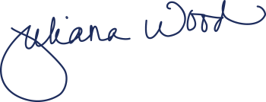

Title: _______Managing Director___________________

Initials: JMW

Applicant:

Print Name:

Signature:

Title: ________ ________________________

Initials:

Exhibit B

Certification Mark

CIRQ Certification Marks for use by companies certified to the applicable standard(s):
(According to the Terms in Exhibit C):

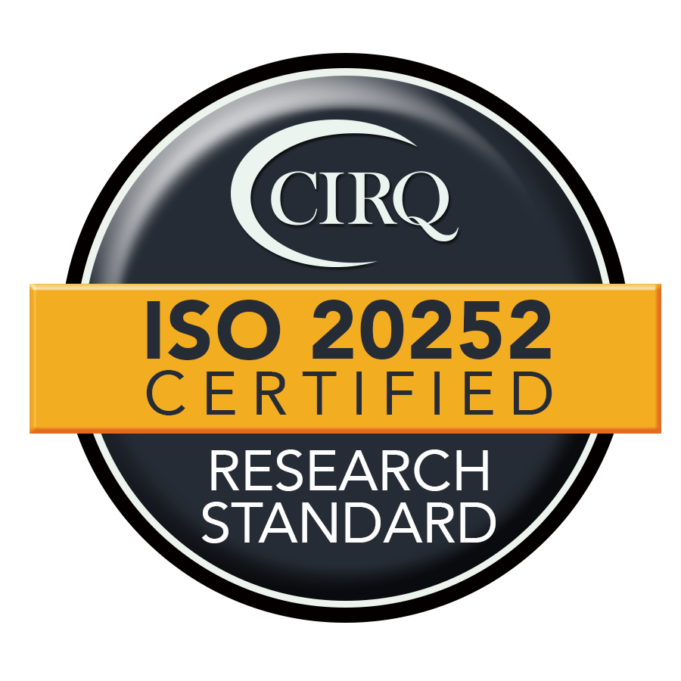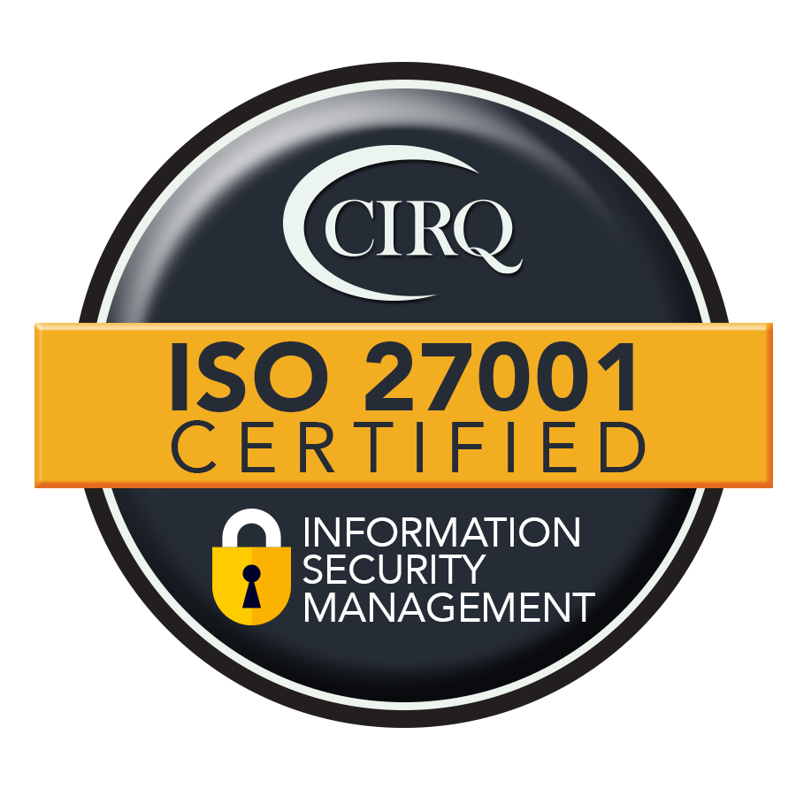

Exhibit C

Terms of Use for CIRQ Certification Mark
- The Insights Association’s Certification Institute for Research Quality, LLC. (“CIRQ”) has established these Terms of Use to allow for the use of the CIRQ Certification Mark(s) in a professional and legal manner by CIRQ-certified companies in their written and electronic literature and advertising. These Terms define the limitations of use by ISO 20252:2019 and ISO/IEC 27001:2022 (the “Standard(s)”) certified companies of the CIRQ Certification Mark(s); and will be administered by the CIRQ Managing Director and CIRQ Board Chair. These terms cover the use of the CIRQ Certification Mark(s) only. The CIRQ logo is a separate and distinct graphic and is restricted to CIRQ use only.
- Only companies who have achieved a successful audit to the Standard and have received a Certificate of Compliance from CIRQ are permitted to use the CIRQ Certification Mark(s). The client conforms to CIRQ requirements when making reference to its certification status in communication media such as the internet, brochures or advertising, or other documents.
- CIRQ does not permit its marks to be applied by certified clients to laboratory test, calibration or inspection reports or certificates.
- The CIRQ Certification Mark(s) will be delivered to the certified company electronically in both a gif format for website use and a jpeg format for print use. Other formats will be made available as needed. Guidelines for size and color usage will be delivered with the Certification Mark(s).
- Certification approval and use of the Certification Mark(s) is limited to the scope of audit determined by CIRQ and detailed on the Certificate of Compliance in the Statement of Applicability. Companies who have achieved certification will use the Certification Mark(s) only in such a way so as not to create confusion between matters referred to in the scope of certification and other matters and does not make or permit any misleading statement regarding its certification.
- Divisions, parents, subsidiaries, sister companies and other affiliated companies are not permitted to use the CIRQ Certification Mark(s) unless they have individually received certification by CIRQ to the Standard(s).
- Companies that have achieved certification but are not Insights Association members may only use the CIRQ Certification Mark(s) and are not entitled to use the separate and distinct Insights Association logo in their materials.
- The use of CIRQ’s name and/or the Certification Mark(s) and/or the use of the Insights Association name and/or logo are not an endorsement of the organization that use any such name, Certification Mark(s), or logo. The CIRQ name and Certification Mark(s) and the Insights Association name and logo shall in no way imply that the product, process or service is certified by this means.

- The CIRQ Certification Mark(s) applies only to certification of either/both the company’s research project management system (ISO 20252:2019) or information security management system (ISO/IEC 27001:2022) according to the Statement of Applicability. The statement of certification is limited to:
— identification (e.g., brand or company name) of the certified client
— the type of management system (e.g., research process or information security) and the applicable standard
— CIRQ as the certification body issuing the certificate
Note: Specific to ISO 27001:2022, the client does not allow reference to its information security management system certification to be used in such a way as to imply that CIRQ certifies a product (including service) or process.
- The use of the CIRQ Certification Mark(s) following initial certification is subject to annual review based on the successful result of subsequent annual surveillance audits or the re-certification audit. The client shall amend all advertising matters when its scope of certification has been reduced.
- CIRQ reserves the right to suspend or withdraw a company’s certification under the Standard and its use of the CIRQ Certification Mark(s) based on failure to comply with the Standard as determined by the outcome of a CIRQ audit, violation of conformance to the standard, or misuse of the Certification Mark(s). Upon withdrawal of its certification, the client discontinues its use of all advertising matter that contains a reference to certification, as directed by CIRQ.
- These Terms of Use are subject to review and revision, the continued use of the Certification Mark(s) after any such revision will be subject to such revised Terms of Use.
- The CIRQ name and Certification Mark(s) are trademarks of CIRQ. CIRQ and Insights Association reserve the right to require that an organization in violation of trademark usage remove them from the organizational website and discontinue use of them should it be determined there is a breach of any conditions laid out in these Terms.
- CIRQ recommends the following language for use in promotional materials in relation to a company’s CIRQ certification: [Insert company name]
  - is committed to industry quality and maintains certification to ISO 20252:2019 the International Standard for Market, Opinion and Survey Research including Insights and Data Analytics. This certification covers [insert Statement of Applicability].
  - is committed to industry quality and maintains certification to ISO/IEC 27001:2022 the International Standard for Information technology — Security techniques — Information security management systems. This certification covers [insert Statement of Applicability].
Note: Either a), b), or c) shall use the additional language: For the avoidance of doubt, at the time of the expiry of a Certificate (or any renewal thereof), [insert company name] will, and shall cause all of its employees, officers, directors, affiliates and agents, to remove any and all public and external-facing promotional and other materials which include or reference [insert company name] as having the Certificate or otherwise imply that it is currently certified by CIRQ.

